**How to debug any external jar using Eclipse**  
(such as “mcf-lap-connector.jar” from ManifoldCF v1.9)  
See also ManifoldInAction chapter 4.

**Problem**We are getting the following error when ManifoldCF checks the authorization of a user against our LDAP authority connection:  
  
This indicates that authorization against our LDAP authority connection is failing.  
  
**Note**: We know this is our LDAP authority connection, because the error value “My+First+Authority+connection” is the description of our connection:  
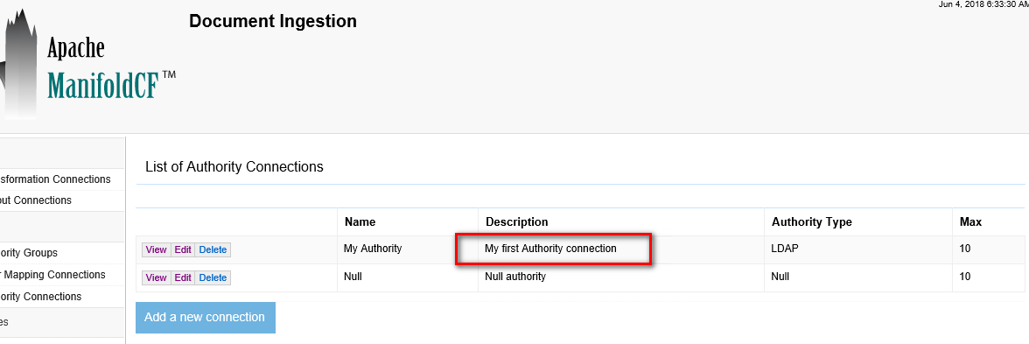  
  
When we run this curl command, the following error is reported in the manifold.log file:  
  
WARN 2018-06-04 04:45:31,918 (Auth check thread 5) - Authority error: [LDAP: error code 32 - 0000208D: NameErr: DSID-03100238, problem 2001 (NO_OBJECT), data 0, best match of:

        'DC=eDP,DC=lab'

 ]

[org.apache.manifoldcf.core.int](http://org.apache.manifoldcf.core.int/)erfaces.ManifoldCFException: [LDAP: error code 32 - 0000208D: NameErr: DSID-03100238, problem 2001 (NO_OBJECT), data 0, best match of:

        'DC=eDP,DC=lab'

 ]

        at org.apache.manifoldcf.authorities.authorities.ldap.LDAPAuthority.getUserEntry(LDAPAuthority.java:995)

        at org.apache.manifoldcf.authorities.authorities.ldap.LDAPAuthority.getAuthorizationResponseUncached(LDAPAuthority.java:349)

        at org.apache.manifoldcf.authorities.authorities.ldap.LDAPAuthority.getAuthorizationResponse(LDAPAuthority.java:331)

        at org.apache.manifoldcf.authorities.system.AuthCheckThread.run(AuthCheckThread.java:96)

Caused by: javax.naming.NameNotFoundException: [LDAP: error code 32 - 0000208D: NameErr: DSID-03100238, problem 2001 (NO_OBJECT), data 0, best match of:

        'DC=eDP,DC=lab'

 ]; remaining name 'ou=TestUsers,dc=eDP,dc=lab'

        at com.sun.jndi.ldap.LdapCtx.mapErrorCode(LdapCtx.java:3179)

        at com.sun.jndi.ldap.LdapCtx.processReturnCode(LdapCtx.java:3100)

        at com.sun.jndi.ldap.LdapCtx.processReturnCode(LdapCtx.java:2891)

        at com.sun.jndi.ldap.LdapCtx.searchAux(LdapCtx.java:1846)

        at com.sun.jndi.ldap.LdapCtx.c_search(LdapCtx.java:1769)

        at com.sun.jndi.toolkit.ctx.ComponentDirContext.p_search(ComponentDirContext.java:392)

        at com.sun.jndi.toolkit.ctx.PartialCompositeDirContext.search(PartialCompositeDirContext.java:358)

        at com.sun.jndi.toolkit.ctx.PartialCompositeDirContext.search(PartialCompositeDirContext.java:341)

        at javax.naming.directory.InitialDirContext.search(InitialDirContext.java:267)

        at org.apache.manifoldcf.authorities.authorities.ldap.LDAPAuthority.getUserEntry(LDAPAuthority.java:989)

        ... 3 more

 WARN 2018-06-04 04:45:31,919 (qtp1680503330-300) - Authority 'My first Authority connection' is unreachable for user 'Adrian.Bailey@edp.lab'

**We want to debug this ManifoldCF function LDAPAuthority.getUserEntry(). This document exlpains how to do this…**

**Step 1: Determine which jar file contains LDAPAuthority.class**I used by “jars” function to do this:

|  |
| --- |
| /cygdrive/d/manifoldv19/apache-manifoldcf-1.9 jars /cygdrive/d/tmp_manifoldjars cd /cygdrive/d/tmp_manifoldjars  $ fl LDAPAuthority.class  ./mcf-ldap-connector/org/apache/manifoldcf/authorities/authorities/ldap/LDAPAuthority.class |

=> The jar file is mcf-ldap-connector.jar, which can be found here in the bin package:   
./connector-lib/mcf-ldap-connector.jar

**Step 2: Create a new Eclipse project and point to the jar file.**1) Create a new Eclipse Java project, called “ManifoldCF”.  
2) Select our new "ManifoldCF" Java project and select "Project > Properties".  
3) Select "Java Build Path".  
4) Click on "Libraries" tab.  
5) Click "Add External JARs...".  
6) Enter the full path to D:\Manifoldv19\apache-manifoldcf-1.9\connector-lib\mcf-ldap-connector.jar.  
7) Go back to "ManifoldCF" in the project view. You should now see a sub-category called "Referenced Libaries".  Expand this.  
8) Right-click on our jar and select "Attach Source > Decompiled Source".  
9) Expand the jar and you should be able to double-click on "LDAPAuthority.class" which should then be visible to create breakpoints in.  
  
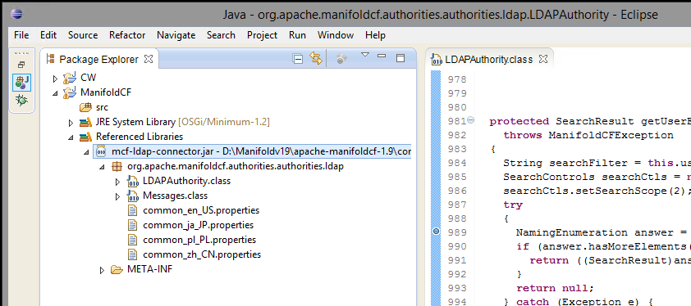  
  
  
**Step 3: Edit the ManifoldCF start.bat script.**ManifoldCF is started using:  
D:\Manifoldv19\apache-manifoldcf-1.9\example\start.bat

Here we can add the following to the "set JAVAOPTIONS=" line:

set JAVAOPTIONS=-agentlib:jdwp=transport=dt_socket,server=y,suspend=y,address=8000

When we now run start.bat, it will be waiting for Eclipse to attach ("Run > Debug Configurations... etc").  
  
We can then debug in the jar file when we next issue the “curl” command:  
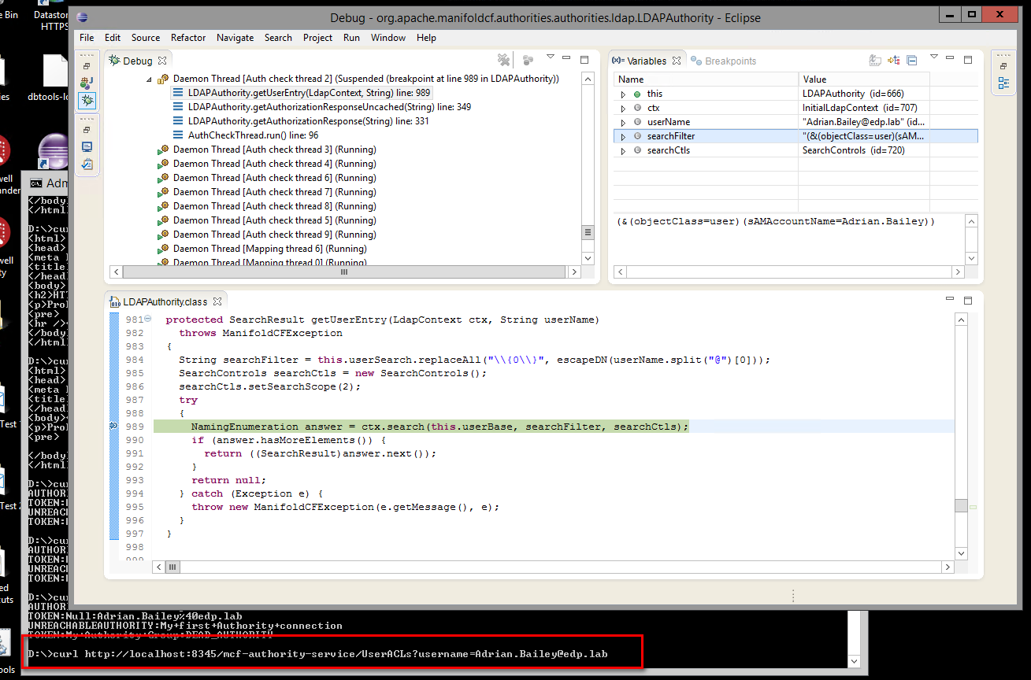

**Step 4: How I fixed the ManifoldCF authorization failure,**I fixed this by using the following ManifoldCF LDAP authority connector settings:  
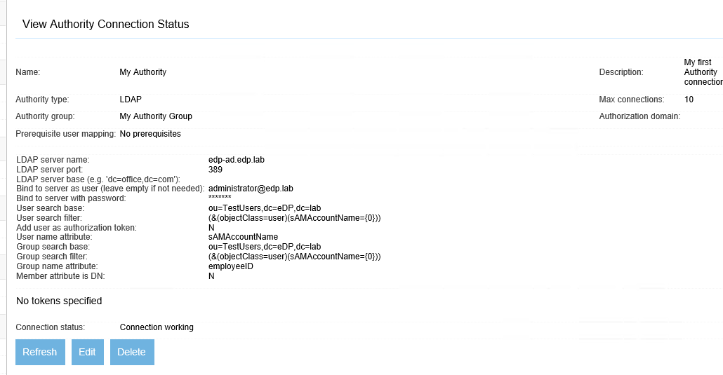  
  
The source code has no helpful comments, so I don't know if the way I've done this is valid/correct, but it definitely works:  
  
D:\>curl <http://localhost:8345/mcf-authority-service/UserACLs?username=Adrian.Bailey@edp.lab>  
AUTHORIZED:Null+authority  
TOKEN:Null:Adrian.Bailey%40edp.lab  
AUTHORIZED:My+first+Authority+connection  
TOKEN:My+Authority+Group:60

Here you can see that my LDAP authority connection ("My first Authority connection") is now "AUTHORIZED". But I really have no idea what the concept of "Group search ..." is for in the ManifoldCF settings. The code indicates that the "Group search" side is optional; however the UI demands that a value be specified. I strongly suspect that this code has been changed in later ManifoldCF versions, i.e. so that only the "User search ..." side need be specified.  
  
Anyway, the point of the exercise was really to verify how we could debug any external lib file such as mcf-ldap-connector.jar, which we've just successfully done :-)

*JeremyC 4-6-2018***END**